Features of C Language

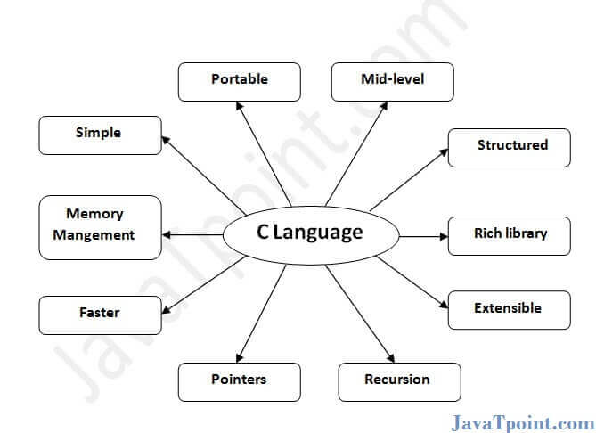

C is the widely used language. It provides many **features** that are given below.

1. Simple
2. Machine Independent or Portable
3. Mid-level programming language
4. structured programming language
5. Rich Library
6. Memory Management
7. Fast Speed
8. Pointers
9. Recursion
10. Extensible

1) Simple

C is a simple language in the sense that it provides a **structured approach** (to break the problem into parts), **the rich set of library functions**, **data types**, etc.

2) Machine Independent or Portable

Unlike assembly language, c programs **can be executed on different machines** with some machine specific changes. Therefore, C is a machine independent language.

3) Mid-level programming language

Although, C is **intended to do low-level programming**. It is used to develop system applications such as kernel, driver, etc. It **also supports the features of a high-level language**. That is why it is known as mid-level language.

4) Structured programming language

C is a structured programming language in the sense that **we can break the program into parts using functions**. So, it is easy to understand and modify. Functions also provide code reusability.

5) Rich Library

C **provides a lot of inbuilt functions** that make the development fast.

6) Memory Management

It supports the feature of **dynamic memory allocation**. In C language, we can free the allocated memory at any time by calling the **free()** function.

7) Speed

The compilation and execution time of C language is fast since there are lesser inbuilt functions and hence the lesser overhead.

8) Pointer

C provides the feature of pointers. We can directly interact with the memory by using the pointers. We **can use pointers for memory, structures, functions, array**, etc.

9) Recursion

In C, we **can call the function within the function**. It provides code reusability for every function. Recursion enables us to use the approach of backtracking.

10) Extensible

C language is extensible because it **can easily adopt new features**.